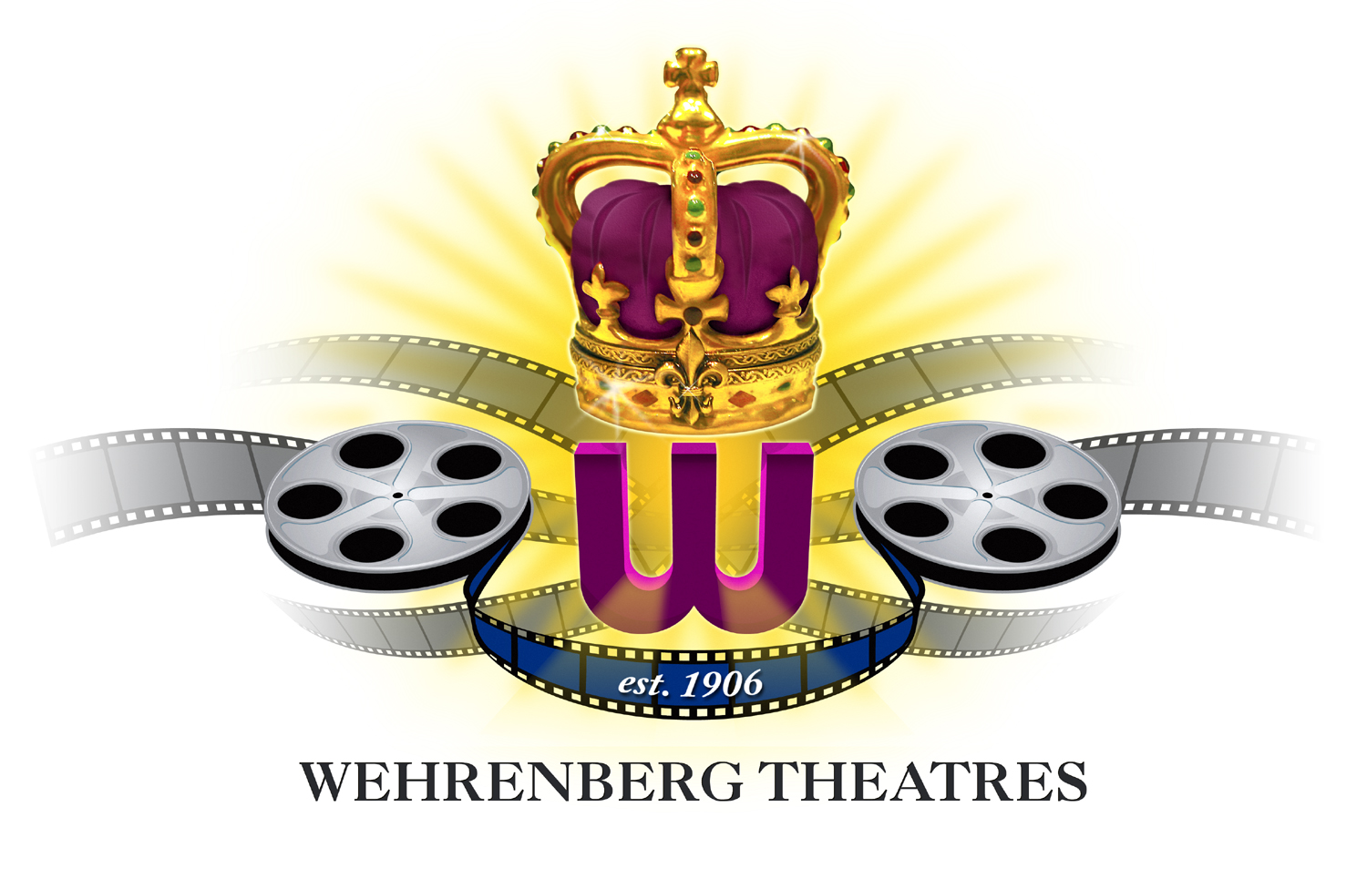

Contact: Kelly Hoskins Phone: 314-640-7640

Wehrenberg Theatres Brings the Opera to the Digital Big Screen
Seven Famed Operas to Play Digitally at Four Local Movie Theatres

St. Louis, MO (March 3, 2008) – St. Louis area residents have a new venue to enjoy the fine arts. Opera is coming to the big screen! Wehrenberg Theatres will show two different series of operas using digital projection. Seven different titles will play locally beginning March 8 and run through mid-May.

San Francisco Opera will introduce four titles to the silver screen. They are La Rondine, Samson and Delilah, Don Giovanni and Madama Butterfly. The other series is from La Scala in Italy. Those shows are La Traviata, Maria Stuarda and Il Trittico. All seven operas are presented in digital projection to ensure the sharpest, crispest images and crystal-clear sound. There is truly no better way to experience an event as moving as an opera.

All seven operas will play at four St. Louis area theatres – the Galaxy 14 Cine in Chesterfield, MO, the Ronnies 20 Cine in south county, the St. Charles Stadium 18 Cine and the O’Fallon 15 Cine in O’Fallon, IL. Pricing and showtimes for the operas are consistent at each theatre. Tickets are $20 and $18 for seniors. Group discounts are also available by calling 314-822-4520. The complete schedule is:

San Francisco Opera Series
La Rondine – Sat., March 8 – Sun., March 9 at 2 PM
Mon., March 10 – Tue., March. 11 at 7 PM
Samson and Delilah - Sat., March 29 – Sun., March 30 at 2 PM
Mon., March 31 – Tue. April 1 at 7 PM
Don Giovanni - Sat., April 12 – Sun., April 13 at 2 PM
Mon., April 14 – Tue., April 15 at 7 PM
Madama Butterfly - Sat., April 19 – Sun., April 20 at 2 PM
Mon., April 21 – Tue., April 22 at 7 PM

La Scala Opera Series
La Traviata - Wed., March 26 at 2 PM and 7 PM
Maria Stuarda - Wed., April 30 at 2 PM and 7 PM
Il Trittico - Thu., May 15 at 2 PM and 7 PM

Note the San Francisco Opera Series will run four days for each show, but with one showing each day. The La Scala Opera Series plays just one day each, but features both a matinee and evening performance.

- more -

Two opera series coming to Wehrenberg Theatres - Page 2 of 2

Tickets for these incredible events are available online at www.wehrenberg.com or by calling 1-800-FANDANGO. Guests can also purchase tickets at a participating theatre box office of their choice.

In addition, a “series pass” can be purchased for the final six operas (excluding only La Rondine). Each “series pass” is a booklet containing an individual admission ticket for each of the final six operas. These booklets are just $90, saving guests 25% off each opera! Booklets can be purchased at any of the four theatres, and each ticket can be used at any theatre showing the opera.

Six of the seven operas are performed in Italian with English subtitles. The exception is Samson and Delilah, which is performed in French. It, too, features English subtitles. Please find the attachments for a synopsis of each opera.

Wehrenberg Theatres currently operates sixteen cines in Missouri, Illinois, Minnesota and Iowa.

Having celebrated its 100th Anniversary in 2006, St. Louis-based Wehrenberg Theatres is the oldest family-owned and operated theatre circuit in the U.S. Ronald P. Krueger, 3rd Generation, Chairman and Co-CEO of Wehrenberg Theatres. Ronald P. Krueger, 4th Generation, President of Theatre Operations.

# # #

